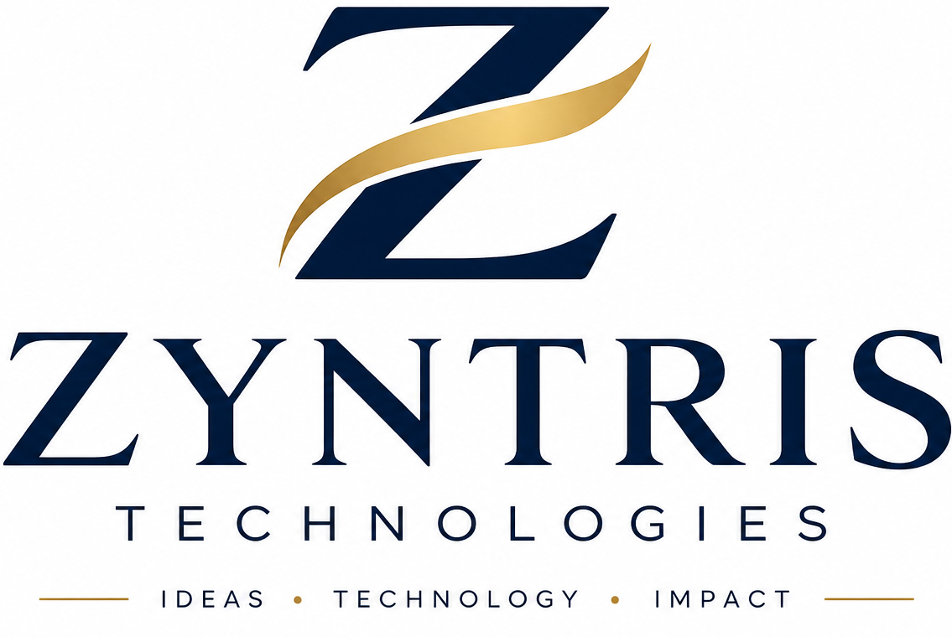
BUSINESS PROPOSAL

Zyntris Operations
Prepared for Lenco Technology Limited
A configurable operations workspace for people, approvals, expenses and cross-team execution
PREPARED BY Zyntris Technologies | DATE 30 October 2026

Executive proposal
We propose deploying Zyntris Operations as a configurable internal work platform for Lenco Technology Limited. It brings employee administration, approvals, expense controls and cross-functional execution into one organization workspace, with access and workflows configured to Lenco’s operating model.
Lenco’s public product materials describe business accounts, payments, expense management and payouts, alongside team access controls. Zyntris is designed to complement that finance offering by organizing the people and internal processes around it. It does not replace Lenco’s banking products or initiate transfers.
Recommended outcome
A dedicated Lenco workspace with selected services enabled, employee and manager access configured, and approval policies aligned to Lenco’s authority matrix. Final scope, commercial terms and release conditions would be agreed with Lenco before activation.

Public product context: Lenco official site | Lenco team access and multi-location controls

Proposed service scope
Lenco can select the modules that fit its internal needs. The platform administrator can activate or disable service areas for the tenant, while Lenco’s own administrators manage staff access and organization workflows.
Operational area | How Zyntris supports Lenco
People and HR | Employee directory, onboarding invitations, role and access assignment, departments, teams, line managers, leave requests, attendance and shift records.
Performance and goals | Team and employee KPIs, goals and OKRs, self-assessment, manager review, 360 feedback, employee response, recommendations and performance-improvement plans.
Payroll records | Compensation and deductions, bank details held for record purposes, payroll validation and employee payslip generation. No bank transfers are initiated.
Expenses and approvals | Expense claims with supporting receipts, request history, comments, returns for correction, approval decisions, and email or in-app notifications where configured.
Budgets and purchasing | Budget tracking, purchase requests, supplier quote comparison, purchase orders, receipt and invoice matching, and finance approval records.
Projects and work | Project portfolios, phases, timelines, dependencies, budgets, timesheets, change control, meetings, reusable templates, tasks and client read-only update links.
CRM and receivables | Customer and opportunity records, sales pipeline, quotes and activity tracking; invoice and receivables records with manual statement import and reconciliation review.
Operations support | Vendor and asset records, internal helpdesk tickets, fleet and dispatch records where relevant, plus dashboards, exports and audit history.

Modular scope
Lenco can start with HR, expenses and approval controls, then enable projects, CRM, receivables or other service areas as operational priorities and commercial scope are confirmed.

How the workflows can support Lenco

Employee onboarding and access
An authorized Lenco HR or organization administrator creates an employee profile, assigns team, manager and access level, and sends an invitation. Employees activate their accounts and complete assigned onboarding information. Organization membership and role permissions govern access to records and actions.

Financial requests and expense claims
Staff submit an expense claim or financial request with the required details and evidence. Lenco can define categories, approvers, approval limits and escalation rules. Approvers can approve, decline or return a request for edits with notes. The requester can follow the status and history in the app; email and in-app notifications can alert the requester and assigned approver.

People management and performance
HR can structure teams, assign line managers and set KPIs. Employees complete self-reviews; managers add their assessments; nominated peers contribute 360 feedback. The review record can include notes, recommendations, employee response and a linked improvement plan. HR can also coordinate leave, shifts, attendance records and exit cases.

Payroll documentation
HR maintains remuneration and deductions, checks payroll inputs, records pay periods and generates payslips. Preflight checks can flag duplicate employees, missing data, unusual deductions, invalid dates or negative net pay before approval. Statutory rates and payroll policy remain configured and professionally verified by Lenco. The module records pay; it does not move money.

Projects, CRM and service operations
Teams can coordinate cross-functional initiatives through portfolios, tasks, milestones, dependencies, budgets, timesheets and meeting records. CRM and receivables features provide operational visibility across customer opportunities and amounts due. These modules support internal coordination and do not constitute a direct integration with Lenco’s customer banking, payment or payout rails.
Illustrative operating pattern
A team member submits a documented request; the configured approver receives an alert; Finance reviews budget and evidence; an approver records a decision or returns it with a note; and the requester sees the outcome in the request history. Lenco defines the roles, limits and fallback rules.

Implementation and governance
We recommend a companywide deployment after configuration and user acceptance. The exact schedule will be agreed with Lenco based on selected modules, user count, data readiness, approvals and any integration requirements.
Operational area | How Zyntris supports Lenco
1. Confirm scope | Nominate an executive sponsor and HR, Finance, Operations, IT and security contacts. Confirm users, modules, data and success measures.
2. Configure | Set up the tenant, organization structure, role matrix, service access, approval limits, workflow fallbacks, notifications and reporting.
3. Prepare and validate | Load approved employee and operational records; validate role boundaries and test onboarding, expenses, payroll checks, reporting and recovery procedures.
4. Enable companywide use | Train administrators, approvers, managers and staff; activate approved access; monitor issues and manage changes under agreed ownership.

Security, data and recovery
Zyntris uses organization-scoped workspaces and role-based access controls. Privileged actions can require multi-factor authentication; browser sessions use secure cookies; passwords are stored as strong hashes with server-side peppering; and key actions are recorded in audit history. Uploaded files are held in private R2 storage with tenant-scoped paths.
A separate Cloudflare account and private R2 bucket have been configured as the independent backup destination for production. The end-to-end backup write and a restore drill against a dedicated test tenant still need to be completed and recorded. Lenco-specific retention, recovery objectives, incident contacts and access-review procedures should be agreed before relying on backups for recovery.

Scope boundaries and integrations
- Zyntris payroll records compensation and generates payslips; it does not initiate salary transfers.
- No direct Lenco banking, payout, account or payment API integration is included or represented as live. Any integration requires a separate technical, security and commercial assessment.
- Google or Microsoft calendar synchronization requires provider credentials, tenant authorization and production validation. The in-app calendar is separate.
- The mobile application is separate from the web workspace; app-store publication and operating-system push notifications require their own release work.
- Lenco remains responsible for employee data accuracy, approval authority, statutory payroll settings, retention decisions and applicable legal requirements.

Commercial approach
Pricing will be prepared after confirming active-user volume, selected services, implementation needs, data migration, support expectations and any integrations. The commercial schedule will identify subscription and implementation charges, optional work, support terms and applicable taxes. Subscription activation is arranged manually through the Zyntris Business Development Manager; the platform does not process subscription payments.

Measures and acceptance
At discovery, Zyntris and Lenco can agree operational measures and establish baselines. Examples include employee profile completion, onboarding invitation success, approval turnaround, returned expense claims, leave processing time, payroll preflight completion, overdue task visibility, and audit-record completeness. No savings or performance percentage is guaranteed in advance.
Operational area | How Zyntris supports Lenco
Access and adoption | Invited users activate accounts, receive correct role access and can complete their assigned workflows.
Finance controls | Requests retain supporting evidence, approval outcomes and notes; configured routing and notifications behave as agreed.
HR and payroll readiness | Employee, leave, appraisal and payroll records are accessible to authorized roles; payroll validation issues are reviewed before approval.
Operational visibility | Managers and administrators can see assigned tasks, project progress and available reports for their permitted scope.
Recovery evidence | A backup is written to the independent destination and a non-production restore drill is documented before recovery readiness is claimed.

Recommended next steps
- Appoint an executive sponsor and working contacts from HR, Finance, Operations, IT and Security.
- Confirm the service modules, user count, role matrix, approval authority and required data migration.
- Identify any desired connections to Lenco systems and provide the relevant API/security review path.
- Agree implementation responsibilities, support arrangements, success measures and the commercial schedule.
- Complete user acceptance and backup recovery verification before the agreed companywide release date.
Proposal decision
We invite Lenco Technology Limited to authorize discovery and commercial scoping for a configurable Zyntris Operations workspace. Final scope, pricing, schedule, support commitments and integration terms will be recorded in a mutually approved order form or service agreement.

ZYNTRIS TECHNOLOGIES | zyntris.org

